**3.2 Non-functional Requirements**

***3.2.1 User Interface***

Our application is thought to be used both via web and via mobile application.

Here we provide some sketches of the pages we consider the most important.

This is the HOME page, where the user can log in or sign up for myTaxiService.

There are only two button: LOGIN and SIGN UP

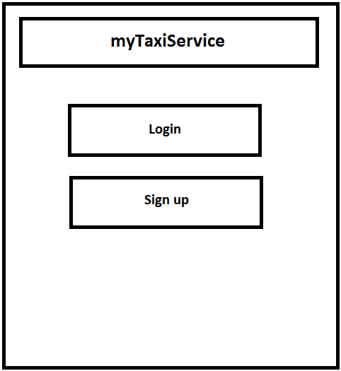

This image is the PERSONAL HOMEPAGE page, where the user can manage his infos, call or book a taxi and, if a previous taxi was booked, modify the the details about that ride.

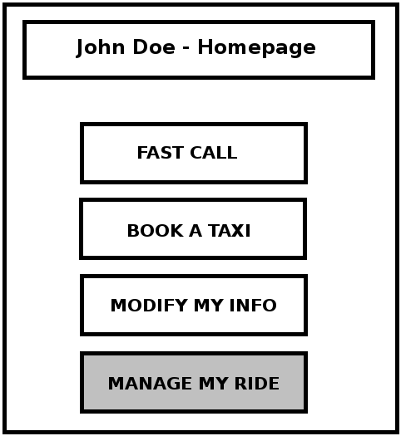

Here is the “Fast Call” interface where a user has only to insert the destination address, the number of passenger and choose if share or not the trip with other people.

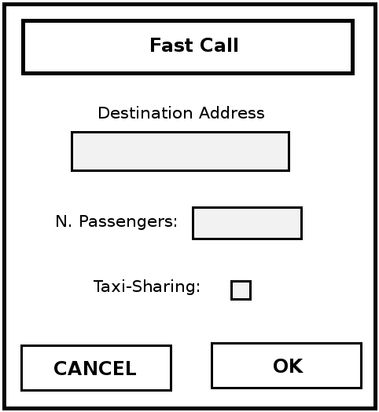

This is the “Book a ride” interface where the user insert origin and destination address, the number of passenger, the date and hour of the ride and so choose whether share or not the trip with other people.

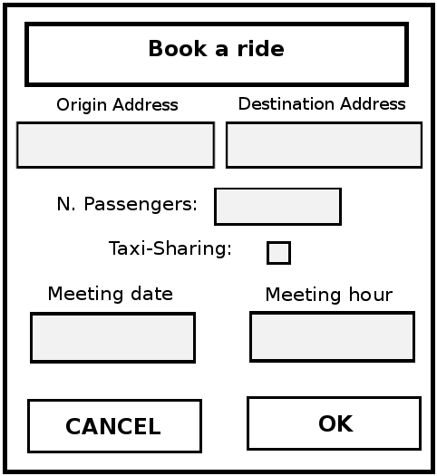

Before confirming a booking or a fast call it's presented a intermediate page where the user can chose to confirm or refuse after having seen the minimum and maximum price for the ride.

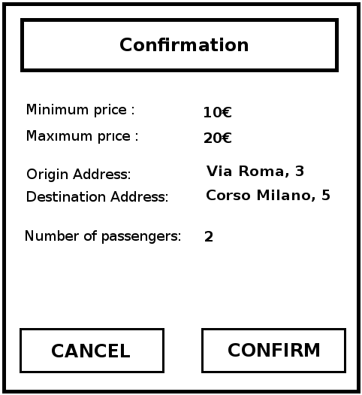

After having confirmed the user can see all the information about his trip, including the taxi code and the estimated Taxi Arrival Time.

